**Describe the process to enable BigQuery to efficiently query the Google Trends data from Cloud Storage ?**

Ans: We just need to create a external table in BigQuery either using webUI or DDL.

If we are using webUI then we must ensure that we change the default table type from “Native Table” to “External Table”. If we forget to do this will result in a static table that won’t load our files into the table.

Please refer below images.

1. First image talks about googleTrendFile location in GCS
2. In the second image, i have created an external table over gcs google trends file and queried it.

Image - 1

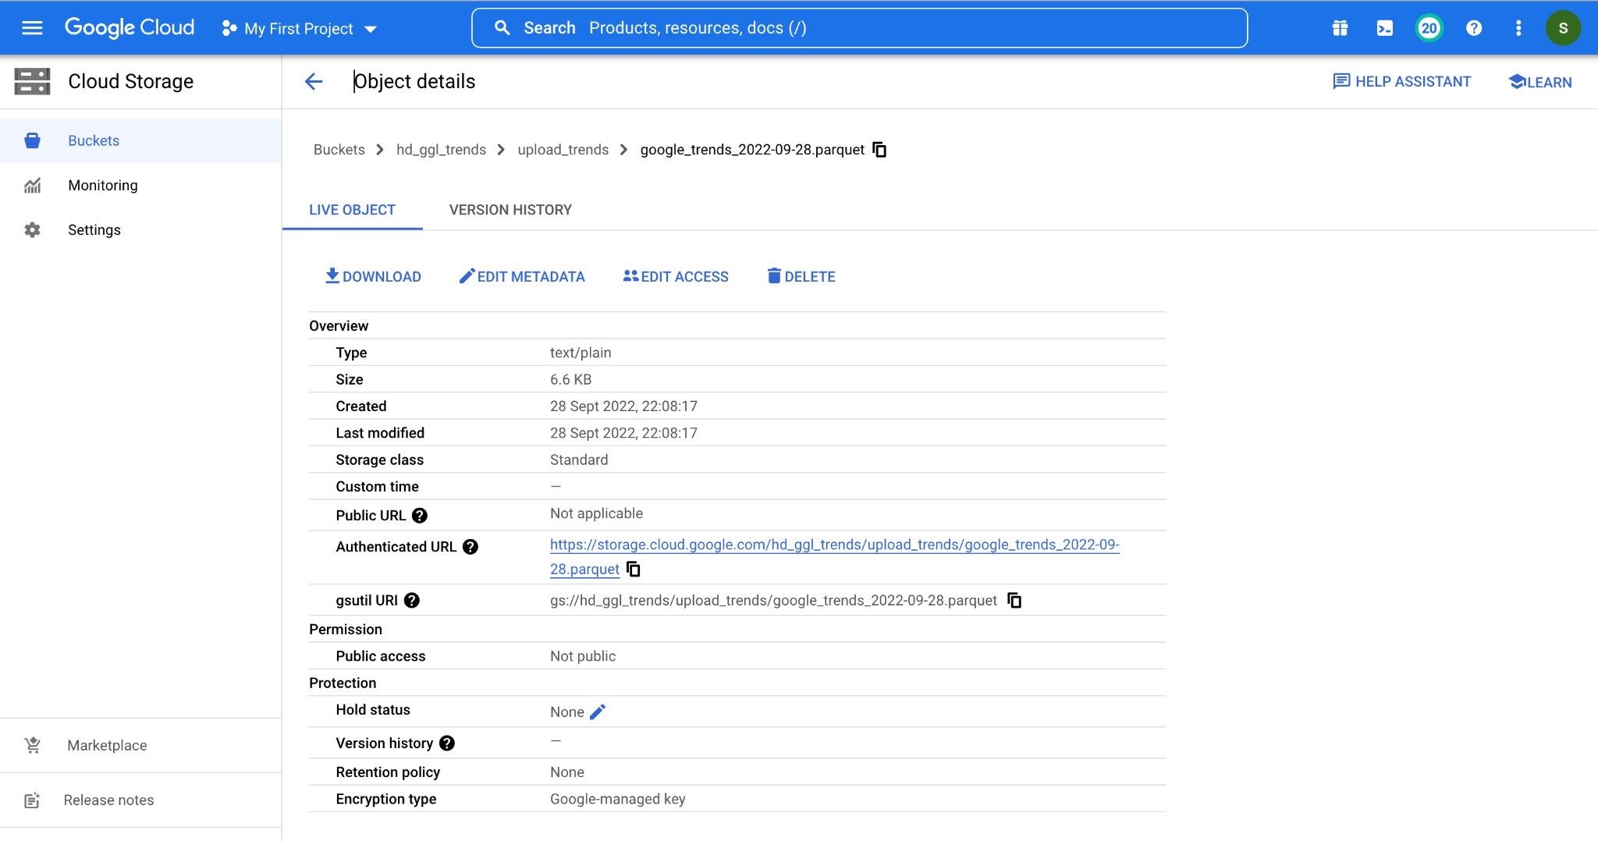

Image - 2:

